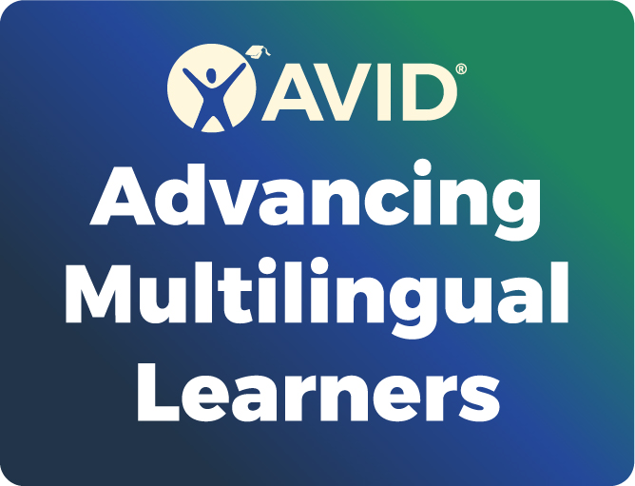

**Webinar Series FAQ:**

**FAQ: AVID's Advancing Multilingual Learner Suite of Resources**

Below is a collection of frequently asked questions based on feedback and inquiries from our recent webinars. This document addresses common themes and clarifies AVID's resources for multilingual learners.

**Redefining Long-Term English Learner Success  
Tuesday, February 25, 2025**

**I previously taught AVID Excel, but my county informed me that it did not meet the California criteria for a primary designated ELD curriculum. What are some ways that districts in California are able to implement this curriculum for designated ELD while ensuring compliance?**

We have a comprehensive crosswalk that demonstrates how the AVID Excel curriculum aligns with the California ELD Standards. For that support resource, email us at [excel@avid.org.](mailto:excel@avid.org)

**Can 7th and 8th grade students be in the same AVID Excel class?**

It isn't ideal, since the curriculum scaffolds through each grade level. However, if it's not possible and you don't have enough students to run two sections, a combo class could work.

**Where can my team access Scholar Starters? Are they available on the AVID website?**

Scholar Starters are integrated into the AVID Excel curriculum and daily lessons.

**Does the AVID Excel curriculum include 180 days of instruction?**

Yes, it does!

**Does AVID offer a K–12 curriculum for English language learners at all levels?**

AVID Emerge provides a PreK–12 toolkit and professional learning to support language learners at all proficiency levels. AVID Excel is a one-period, middle school elective class with its own curriculum. Academic Language and Literacy is designed to provide scaffolds, routines, and strategies to be used in K–12 grade level or content area classrooms to support ML achievement. For more information, please reach out to [excel@avid.org](mailto:excel@avid.org).

**Is there an AVID Excel sampler?**

[Click here](https://explore.avid.org/wp-content/uploads/2024/04/AVID-Excel-Curriculum-Preview.pdf) to access our curriculum sampler.

**Does the ELD period (time of day) matter? At the last middle school where I taught, it was 6th period. I found that students were drained by that time, so I had it moved to 1st period. However, I found that some students weren’t quite ready (awake enough!) for it.**

The AVID Excel Elective class can be offered at any time during the regular school day. While there may be challenges associated with offering it too early or too late in the day, the lessons are based on the AVID Foundations of Instruction and specifically address creating the appropriate environment and building powerful relationships. These two foundations help set the norms for classroom engagement and may help overcome some of the larger environmental challenges.

**Are AVID classes considered ELD classes or are they combined with another academic class?**

AVID Excel Elective is a separate class period with its own curriculum. In some states, it can serve as the ELD class. AVID Excel is a one-period, middle school elective with its own curriculum. For more information, please reach out to [excel@avid.org](mailto:excel@avid.org).

**Small Shifts That Make Big Lifts: Daily Instruction for Elementary Multilingual Scholars  
Thursday, January 30, 2025**

**How do we access the AVID Emerge Elementary Toolkit?**

You can request a sampler of the AVID Emerge Elementary Toolkit by clicking the button on our webpage: [AVID Emerge](https://explore.avid.org/avid-emerge/). If you’re ready to subscribe to AVID Emerge Elementary, registration opens in February for the Summer Institute and Ignite opportunities. Your event registration will include the toolkit subscription. You can also find all upcoming professional learning events on our webpage.

**Do you have any resources for the chants?**

Chants are incorporated throughout the AVID Emerge Elementary instructional routines.  
They are used alongside Total Physical Response (TPR) to help convey the meaning of  
unfamiliar words.

**Classroom Cornerstones: Advancing Multilingual Learners Through the Five Foundations of Instruction**

**Tuesday, December 3, 2024**

**Is AVID Emerge a class like the AVID Excel Elective?**

AVID Emerge is not a stand-alone class like the AVID Excel Elective. It is a toolkit of resources accompanied by professional learning designed to integrate into adopted English Language Development (ELD) curriculum or used as a base for ELD content development.

AVID Emerge is not a comprehensive curriculum but a suite of routines, strategies, and resources for PreK-12 educators to enhance instruction and accelerate language acquisition for multilingual learners at all proficiency levels. To find out more about AVID Emerge, visit <https://explore.avid.org/avid-emerge/>.

**What is necessary for teachers to access AVID Academic Language and Literacy (content-based integrated ELD)?**

Educators must be at an AVID member district or site to access the Academic Language and Literacy (ALL) resources and attend the ALL Community of Practice (CoP) professional learning. You can register for the ALL CoP through MyAVID event registration. The ALL CoP is offered at all Summer Institutes (in-person professional learning) and Ignites (virtual professional learning) or can be offered as a Path training in your district or region.

The ALL curriculum guide, handouts, and instructional videos are available on the MyAVID curriculum book webpage. Additional elementary ALL resources are available on the [core strategies webpage](https://my.avid.org/curriculum/core_strategies.aspx?id=28429).

**Are these resources available to everyone, or must you be an AVID member?**

AVID Emerge is available to all schools and can be used as part of broader school or district initiatives, not just in AVID member districts. Access to the other offerings—Academic Language and Literacy, ELD Summer Bridge, and AVID Excel—are benefits that come with AVID membership.

**Is there an additional cost for AVID Emerge if you have AVID at your school? What support is provided for implementation?**

AVID Emerge is an annual subscription that includes professional learning (Community of Practice) in year 1 and teacher-based renewal each year after. Please see the [AVID Emerge webpage](https://explore.avid.org/avid-emerge/) for details about pricing and implementation.

**Are the AML offerings approved by the state or on the state adoption list?**

Our Advancing Multilingual Learning resources align with state ELD standards but are not state-adopted curricula. We have crosswalk documents available that detail how the resources align with ELD standards.

**Does AVID Emerge align with WIDA standards and assessments?**

AVID Emerge is aligned with WIDA standards. A WIDA crosswalk, available through the AVID Emerge Digital Toolkit demonstrates how the resources support multilingual learners across proficiency levels. Crosswalks are also available upon request prior to subscribing.

**What resources are available for new arrival students?**

AVID Emerge provides targeted instructional routines for students at the “entering” level of language proficiency. All routines in AVID Emerge have differentiated materials for new arrival students.

**What grade levels does AVID Emerge support?**

AVID Emerge Secondary (grades 6-12) is available 2024-25 and AVID Emerge Elementary (PreK-6) will be available in 2025-26.

**Which WIDA levels are most appropriate for AVID Excel?**

AVID Excel is designed for multilingual learners at WIDA levels 3-4 who are considered Long-Term English Learners (LTELs) or are on their way to becoming LTELs.

**Is there a plan for translating AVID resources into other languages?**

We have some key resources translated into Spanish, the native language of over 90% of our ML audience, and we are creating support resources on how to translate our resources into other native languages.

**Will AVID Emerge be offered as a Summer Institute (SI) Community of Practice?**

Yes, AVID Emerge Secondary and AVID Emerge Elementary will be offered at all Summer Institutes this summer, as well as our Ignites (virtual PL).

If you have further questions, please don’t hesitate to email [multilinguallearners@avid.org](mailto:multilinguallearners@avid.org). Thank you for your interest in AVID’s resources for advancing multilingual learners!